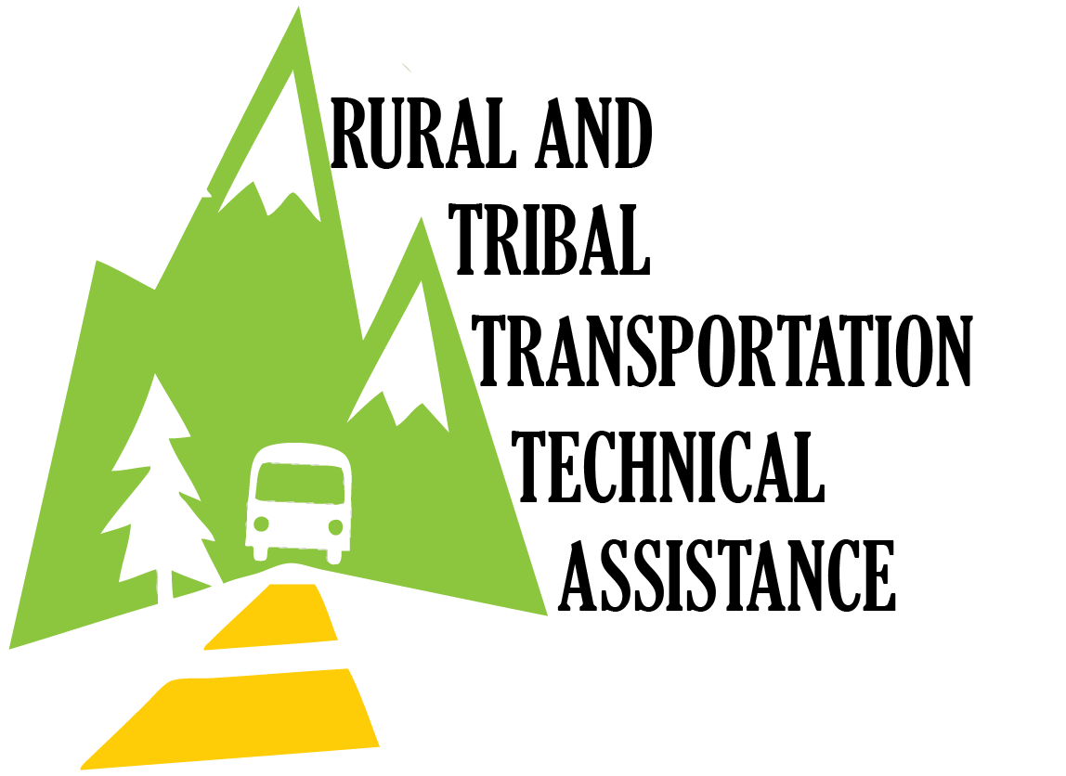
COMMUNITY TRANSPORTATION
ASSOCIATION OF AMERICA

RURAL PASSENGER TRANSPORTATION
TECHNICAL ASSISTANCE PROGRAM

Application For Long Term Technical Assistance

INSTRUCTIONS: The Rural Passenger Transportation Technical Assistance Program helps rural communities enhance economic growth and development by improving passenger transportation services and facilities. Technical assistance provides planning to support transit service improvements and expansion, system start-up, facility development, development of marketing plans and materials, transportation coordination, training and other public transit problem solving activities. Technical Assistance is provided by CTAA staff and consultants and involves on-site and off-site work conducted over a period of eight to twelve months. No local match is required.

Applications for the Technical Assistance Program must be submitted to CTAA by May 3, 2019. Applications received after this deadline will be considered for inclusion in subsequent years of the Program, for inclusion in the current year of the program if a project is withdrawn, or for participation in the short term technical assistance program at a lower level of effort.

Selection of projects is made competitively according to the following criteria:

- Number of new jobs to be created.

- Potential economic impact resulting from implementation of project.

- Level of economic distress in the community.

- Potential for implementation after technical assistance phase of project is completed.

- Demonstrated consensus and support in the community.

- Potential for development of unique or innovative strategies, techniques, or approaches in solving identified problems.

- Potential for replication of the project elsewhere.

Provision of technical assistance is contingent upon availability of funds. Funding for the Rural Passenger Transportation Technical Assistance Program is provided through the Rural Business-Cooperative Service of the United States Department of Agriculture.

The Rural Passenger Transportation Technical Assistance Program is an Equal Opportunity Program
RURAL PASSENGER TRANPORTATION
TECHNICAL ASSISTANCE PROGRAM

Application For Long Term Technical Assistance

APPLICANT: __________________________________________________________________
ADDRESS: __________________________________________________________________
PHONE: ( )_____________ FAX: ( )____________ E-Mail: ___________________
CONTACT PERSON: _____________________________ TITLE: ___________________
DATE: _________________

1. ORGANIZATIONAL CHARACTERISTICS

A. Type of Organization:
_________ Nonprofit corporation * ___ WBE
Government agency * MBE
For profit public corporation* DBE
For profit private business*
Native American organization
Other (Specify)

* Please attach your Articles of Incorporation and Bylaws.

Please complete Sections B-E below on a separate sheet.

B. List the activities in which your organization is involved.

C. Provide a history of your organization's business activities related to transportation. Please document the growth or expansion of your transportation activities since its establishment. Data in Item 4.E. will support this narrative. If you do not currently operate transportation service but are seeking assistance for a new service or facility, check here □.

D. What additional areas will be served as a result of the project?

- If you provide public transportation services, how does your organization establish its fare structure?

F. Do you provide transportation that is open to the general public?
Yes: No: ____

G. Does your organization develop its own budgets? Yes: _____No: _____

H. Is at least 51% of the interest in the organization have membership or is owned by those who are either U.S. citizens or reside in the U.S. after being legally admitted for permanent residence? Yes: No: __
2. TECHNICAL ASSISTANCE REQUEST (Please complete on separate sheet)

A. Summarize the project for which the technical assistance is being sought.
B. Identify specific technical assistance tasks.

- What are the crucial dates for project completion and implementation?

D. Upon completion of the technical assistance, what steps will the Applicant take to implement the recommendations and manage and/or operate the finished project?

E. Describe the Federal, State, local and private sector resources that might be utilized to implement recommendations. Please note that a financing plan can be developed as part of the technical assistance project.

- It is important that State, regional and local officials, as well as other transit operators, be aware of the proposed technical assistance project. Their involvement and support may be critical to later implementation of the project. Please attach letters of support for the project from local officials and the business community. In addition, please list all other public transit operators in your service area and indicate if they are aware of your proposed project.

OPERATOR/AGENCY AWARE OF PROJECT?
YES NO
_____________________ _____ _____
______________________ _____ _____
______________________ _____ _____
______________________ _____ _____
State Department of Transportation _____ _____

3. ECONOMIC BENEFITS
Please estimate the economic benefits that would result from the proposed technical assistance project. Please note that these benefits are estimated, and you are not obligated to attain them.

A. Number of new employees generated by proposed technical assistance project: __________

B. Number of permanent new jobs created in community: __________

C. Number of short-term construction jobs created for facility projects: ________

D. Anticipated annual increase in earnings/revenue as result of technical assistance: $______________

E. Anticipated annual savings resulting from project: $______________

4. TRANSPORTATION SERVICE CHARACTERISTICS
If you do not currently operate transportation service, please check here and proceed to Section 5. ____

A. Ridership by Service Type:
(Each boarding is counted as a one-way trip)

Annual # of Annual # of
Vehicle Miles Passenger Trips
Demand Responsive _____________ _______________
Fixed Route _____________ _______________
Subscription/Contract _____________ _______________
Other _____________ _______________

Total System _____________ _______________

B. Categorical Ridership Breakdown:

Social service agency passengers: ________%

General public passengers: ________%
C. Number of vehicles operated: _______

- Staffing

Number of Drivers: Full time ______ Part time ______
Other positions: Dispatcher ______ Manager ______
Operations Director: ______ Mechanic/Maintenance Director: ______
Other positions (specify) ____________________________________________

Total number of paid staff: ______ Number of volunteers: ______

E. Please provide data for each of the past three years for at least two of the following elements which will demonstrate growth over the period.

2015 2016 2017

Passenger trips ______ ______ _____
Number of Vehicles ______ ______ _____
Revenue ______ ______ _____
Vehicle Miles ______ ______ _____
Vehicle Hours ______ ______ _____
Number of Routes/Services ______ ______ _____
Number of Employees ______ ______ _____

Geographic Service Area 2015: __________________________________________
2016: __________________________________________
2017: __________________________________________

F. Financial Information

Operating Revenue Sources:

Title III Aging $__________________________
Medicaid $__________________________
Section 5311 FTA $__________________________
State $__________________________
Passenger Fares $__________________________
Local (specify)
________________ $__________________________
________________ $__________________________
________________ $__________________________
Other (specify)
________________ $__________________________
________________ $__________________________
________________ $__________________________
________________ $__________________________
________________ $__________________________

Total Operating Revenue $__________________________

5. SERVICE AREA CHARACTERISTICS

A. Population of Applicant's service area:

City/town: ________________ Population:_______________

County: ________________ Population:_______________

B. What is the closest urbanized area to the Applicant's service area:
Urbanized area: Population:

C. Is service area immediately adjacent to an urbanized area?
Yes No ______

D. For each area served by, or anticipated to be served by the applicant, provide the following data. Please indicate sources and dates of information. Use additional sheets if necessary.

 | County | City/Town* | State
NAME
POPULATION
POPULATION DENSITY (persons per sq. mi.)
MEDIAN HOUSEHOLD INCOME
UNEMPLOYMENT RATE **

* Provide data for the municipality where you are located.
** Please indicate source of data and applicable month.

- EQUAL OPPORTUNITY

The following information is requested by the Federal Government for certain types of grants, in order to monitor the grantee’s compliance with equal opportunity laws. You are not required to furnish this information, but are encouraged to do so. The law requires that a grantee may neither discriminate on the basis of this information nor on whether you choose to furnish it. However if you choose not furnish it, this grantee is required to note race/ethnicity on the basis of visual observation or surname. If you do not wish to furnish the above information, please check
here: ___

Note: “Population” refers to the service area population, and “Participants” refers to the number of persons utilizing your organization’s services.
POPULATION PARTICIPANTS
ETHNICITY | No. | % | No. | %
Hispanic or
Latino
Not Hispanic
or Latino
Total
Male
Female

POPULATION PARTICIPANTS
RACE | No. | % | No. | %
American Indian/
Alaskan Native
Asian
Black or African
American
Native Hawaiian
or other Pacific
Islander
White
Total

POPULATION PARTICIPANTS
Gender | No. | % | No. | %
Male
Female

This is an Equal Opportunity Program. Discrimination is prohibited by Federal law. Complaints of discrimination may be filed with USDA, Director, Office of Civil Rights, Room 326-W, Whitten Building, 1400 Independence Ave., SW, Washington DC 20250-9410

******

Return completed application to:
COMMUNITY TRANSPORTATION ASSOCIATION OF AMERICA
Suite 250
1341 G Street, NW
Washington, D.C. 20005

Attention: Charles A. Rutkowski, Director of Technical Assistance Programs

(202) 299.6593
FAX: (202) 737-9197
Email rutkowski@ctaa.org
